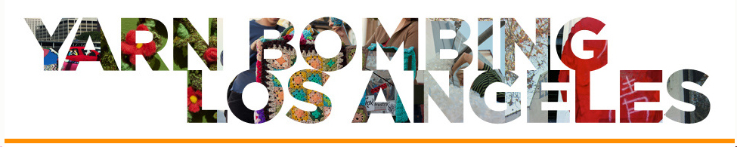
For Immediate Release
May 2013

Contact:
Yarn Bombing Los Angeles
yarnbombing18@gmail.com/pr@cafam.org
www.yarnbombinglosangeles.com
Tel. 310-560-5004

YARN BOMBING LOS ANGELES COVERS THE CRAFT AND FOLK ART MUSEUM IN GRANNY SQUARES May 25⁻July 1, 2013

The knit graffiti collective Yarn Bombing Los Angeles (YBLA) has expanded to include over 500 collaborators in a grass roots effort to crochet CAFAM Granny Squared, a temporary public art installation on the façade of Craft and Folk Art Museum (CAFAM) at 5814 Wilshire Blvd., Los Angeles, CA 90036. CAFAM will hold a VIP and public reception on May 25th, 6-9pm, with a $10 cover charge. However, the installation will be visible to the general public 24 hours a day while it remains on view May 25th-July 1st, 2013.
CAFAM Granny Squared questions the boundaries between art and craft, using scale and color to play with artistic, architectural and institutional identities. YBLA suggests a parallel between how the CAFAM building is dwarfed by the grandiose structures on Museum Row, and how craft is dwarfed by traditional notions of “high art”. To deconstruct this dynamic, YBLA covers CAFAM in colossal graphic patterns to visually shrink it further and make a commentary on artistic and institutional identities associated with craft, a lesser art form by manipulating architecture, often regarded the highest art form.
The project brings together a diverse community of artists and crafters from 50 states and 25 countries who otherwise might not have had access to exhibit their work in a museum, especially in a “fine arts” context. Due to unprecedented participation that yielded to 15,000 five inch granny squares, YBLA has partnered up with Downtown Women’s Center to extend the project in Skid Row until December 2013. Images chronicling the process of CAFAM Granny Squared are available to download at https://www.dropbox.com/sh/fvecgmftcr7577d/Z1wwPVfLCt?n=7954227.

Yarn Bombing Los Angeles (YBLA) is a group of guerrilla knitters who have been collaborating since 2010 to stage public installations and performances to help expand the definition of public art to include self-initiated and temporal urban interventions such as yarn bombing. For more info visit www.yarnbombinglosangeles.com

Yarn Bombing Los Angeles 1653 18th St. #5 Santa Monica, CA 90404 yarnbombing18@gmail.com 310-560-5004
w w w .y a r n b o m b I n g l o s a n g e l e s. c o m

